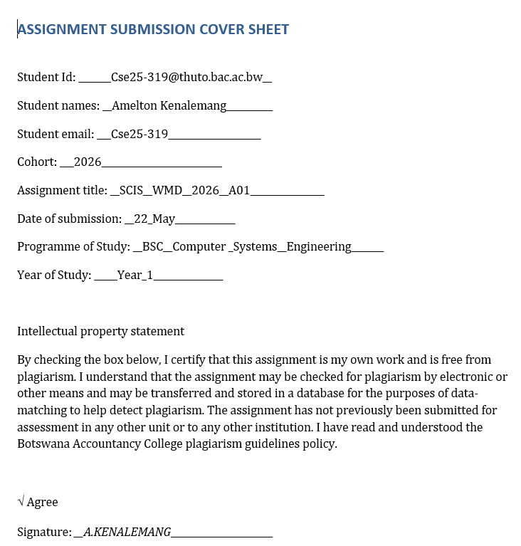

DevLog AK
Website Specifications
The objective of this project is to design and develop a simple personal blog website called DevLog AK for Amelton Kenalemang, a Computer Systems Engineering student. The website will allow users to view personal information, read blog posts and explore projects without creating an account.
The system will include a home page, about page, blog page, projects page and contact page. Each section will present information in a clear and structured way for easy navigation.
The website will use HTML, JavaScript and CSS and will be hosted on GitHub Pages for public access. It will follow a simple design to ensure fast loading and easy use.
This type of website is commonly used by students to showcase skills, projects and learning progress in a personal portfolio format.

References
• GitHub Pages – Website hosting platform.
• HTML, JavaScript and CSS – Core web development technologies.
• Bootstrap – Responsive design framework.
• Google Fonts – Typography styling.

2. Blog Goals
- To design and develop a modern and responsive personal blog website called DevLog AK.
- To create a digital platform that showcases programming knowledge, academic progress and software development projects.
- To build a consistent personal brand identity that reflects growth in Computer Systems Engineering and data science.

3. Target Audience
• Demographics: Students, lecturers, recruiters and developers interested in software and data science.
• Technical Level: Medium to high
Users are expected to understand basic tech concepts and navigate digital content easily.

4. Type of Website & Content
Website Type: Personal Blog / Developer Portfolio
Key Content:
The website includes structured personal and technical content.
Firstly, the website shows personal introduction content including the name Amelton Kenalemang, education and career direction in Computer Systems Engineering.
The platform will also include blog posts that share programming knowledge and project explanations.
The website will also present a projects section that highlights software development work such as applications (a calendar, calculator and weather simulator app developed in JsFiddle coding playground), coding exercise and GitHub repositories.
Finally, a contact section will provide communication links such as email and GitHub for networking.

5. Information Design & Taxonomy

Sitemap & Navigation Paths
• Home Page: Introduction and overview of DevLog AK
• About Page: Personal background and skills
• Blog Page: Programming and learning articles
• Projects Page: Software development work
• Contact Page: Communication details

Taxonomy
DEVLOG AK
├── Home
├── About
├── Blog
│ ├── Java Programming
│ ├── Web Development
│ └── University Notes
├── Projects
│ ├── Web Apps
│ ├── Java Projects
│ └── GitHub Repositories
├── Contact
│ ├── Email
│ └── GitHub Profile

DEVLOG AK SITEMAP
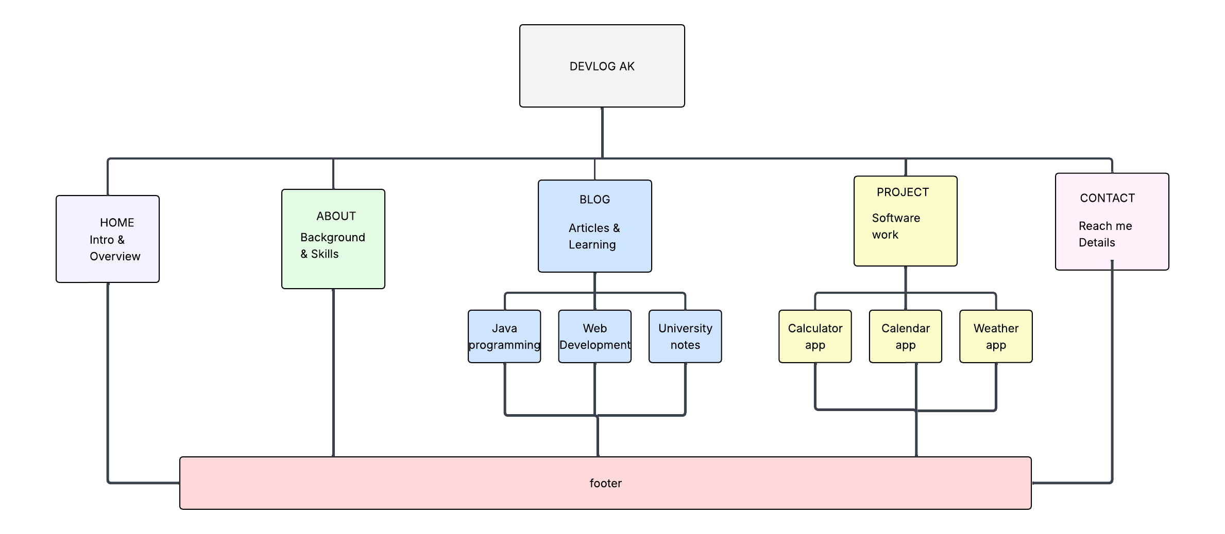

6. Page Template Design
- Simple modern layout with navigation bar.
- Home page includes intro section and featured posts
- Blog page displays post previews in card format.
- Projects page displays project cards with link.
- Wireframes were used to plan the design.
Wireframe concept:

Home page.
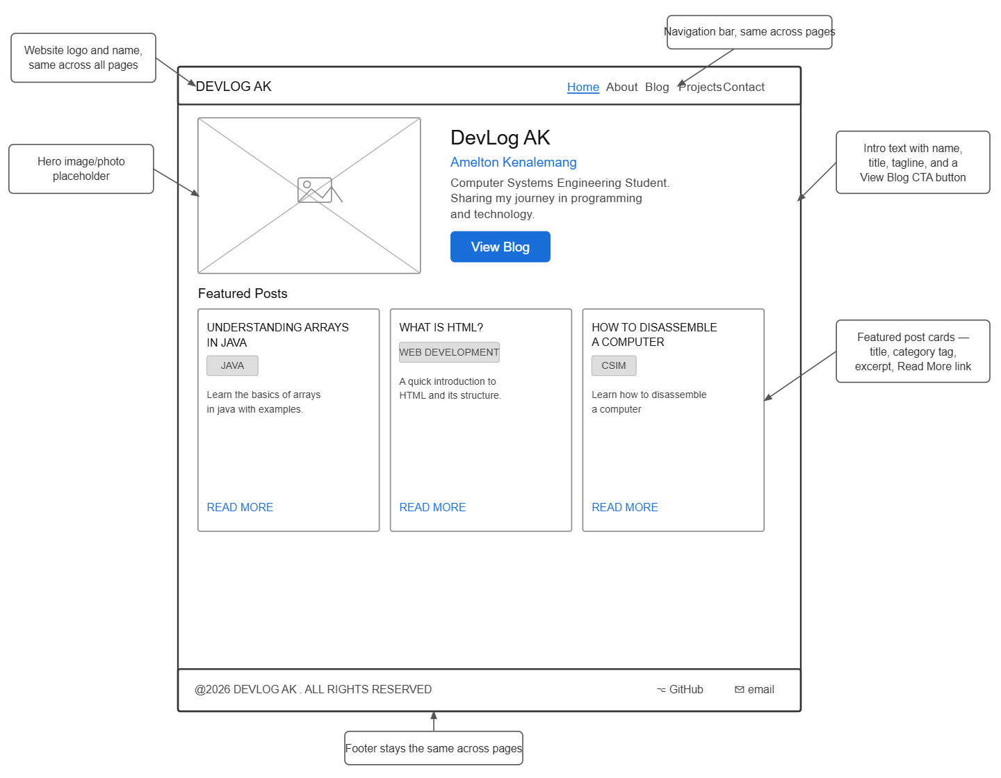

About page.
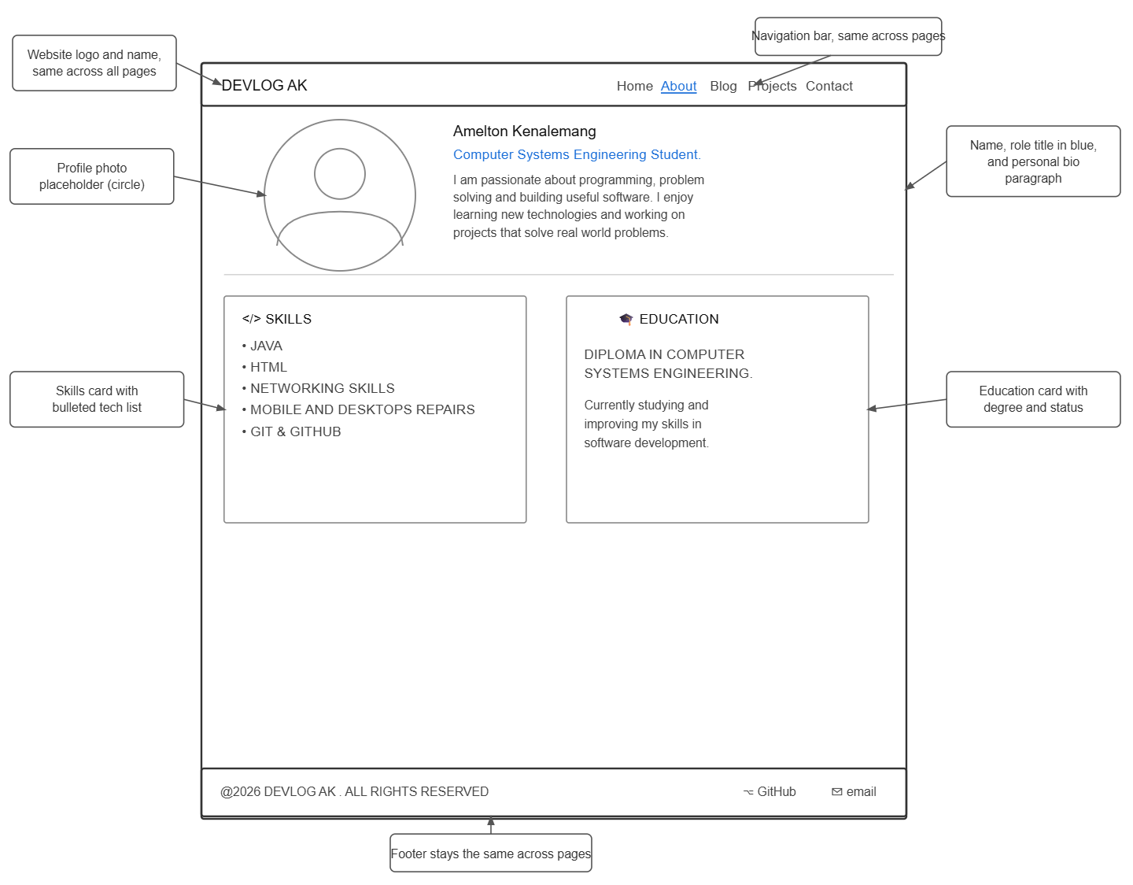

Blog page.

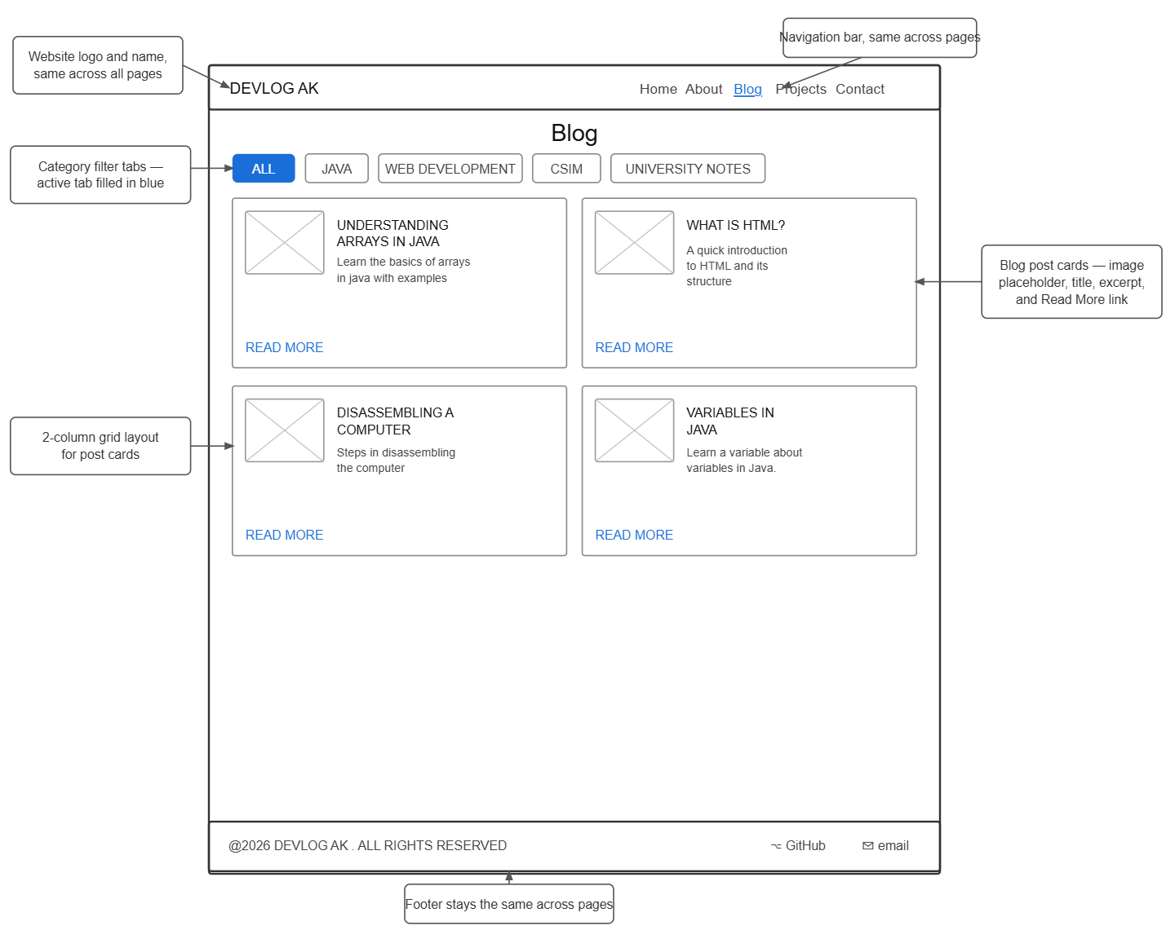

Projects page.


Contact page.
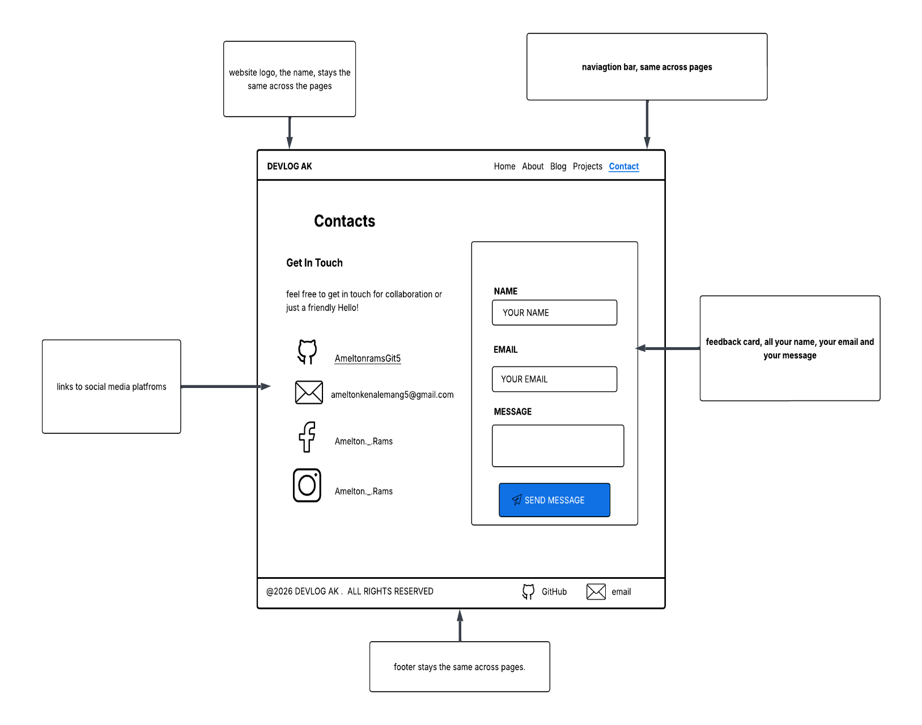

High-end wireframes
Home page.

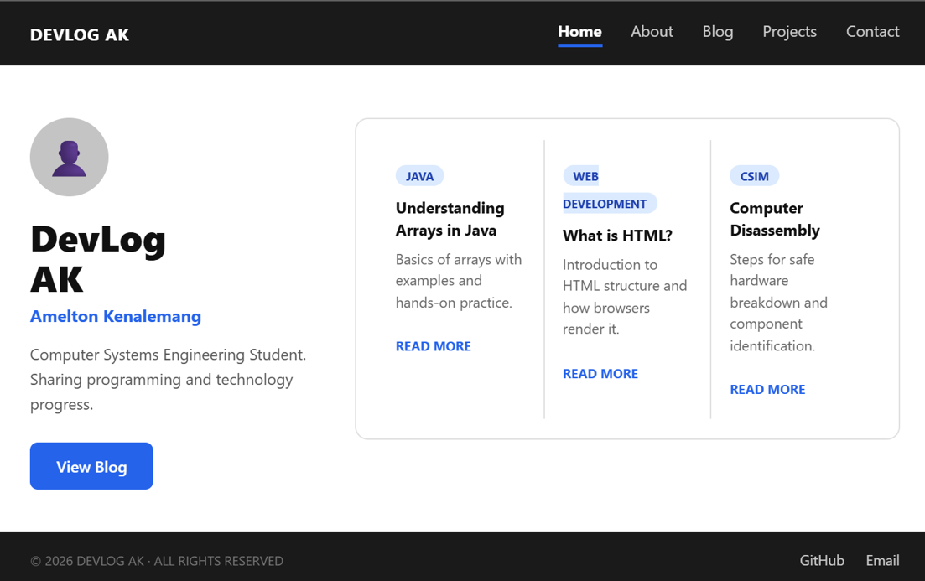

About page.

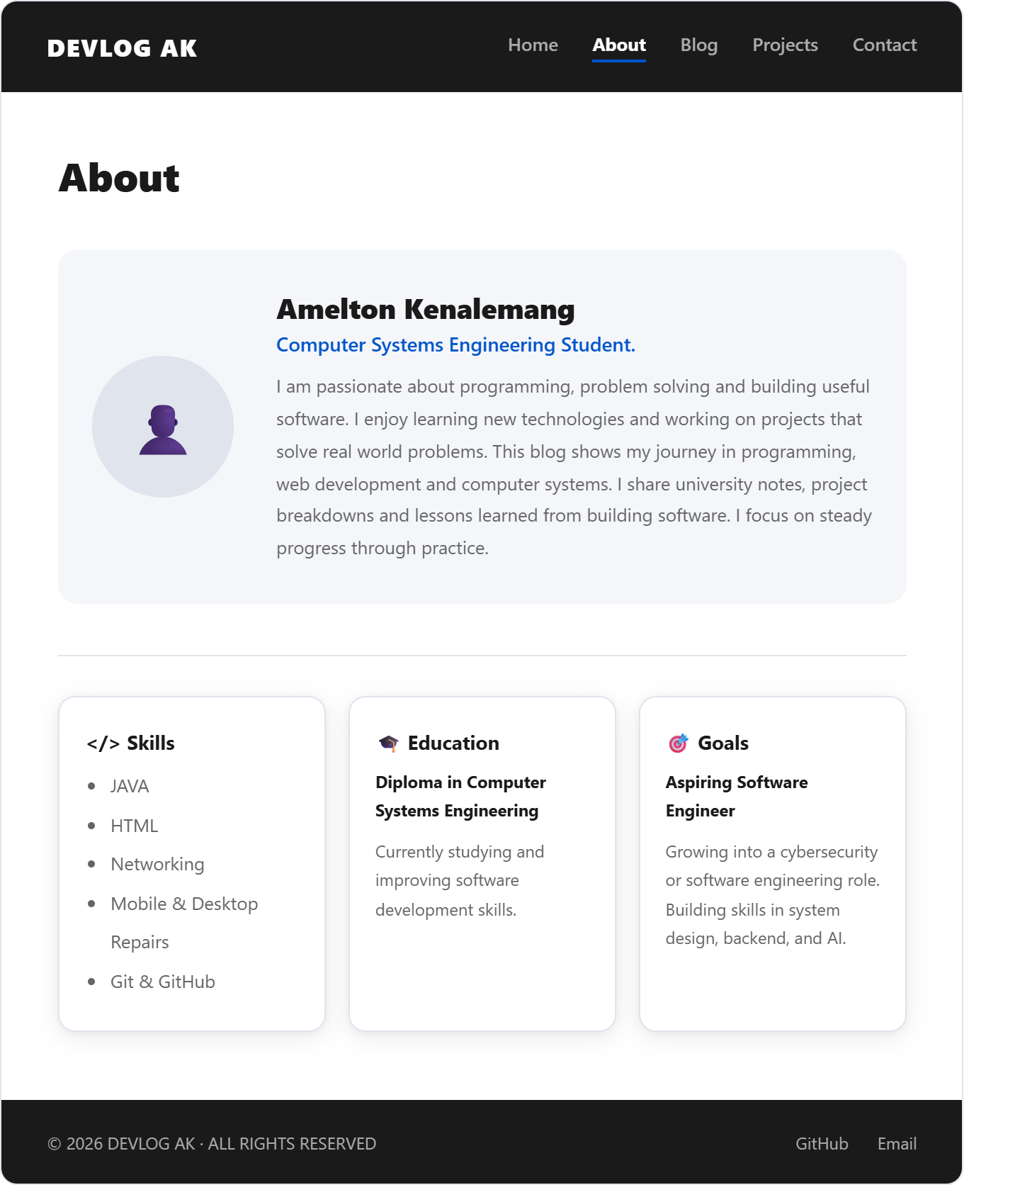

Blog page.

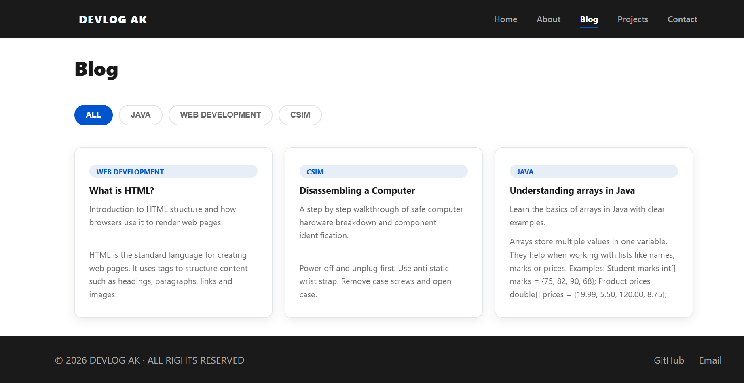

Projects page.

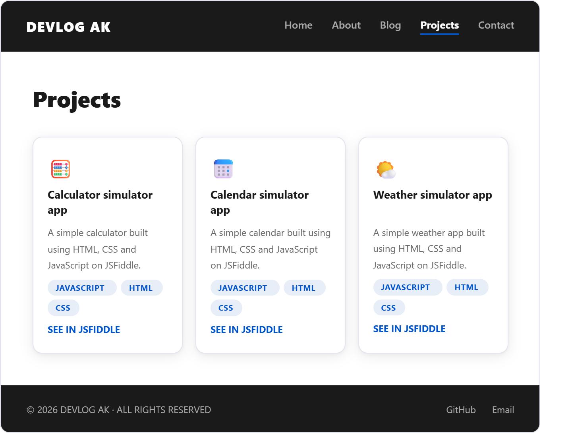

Contact page.

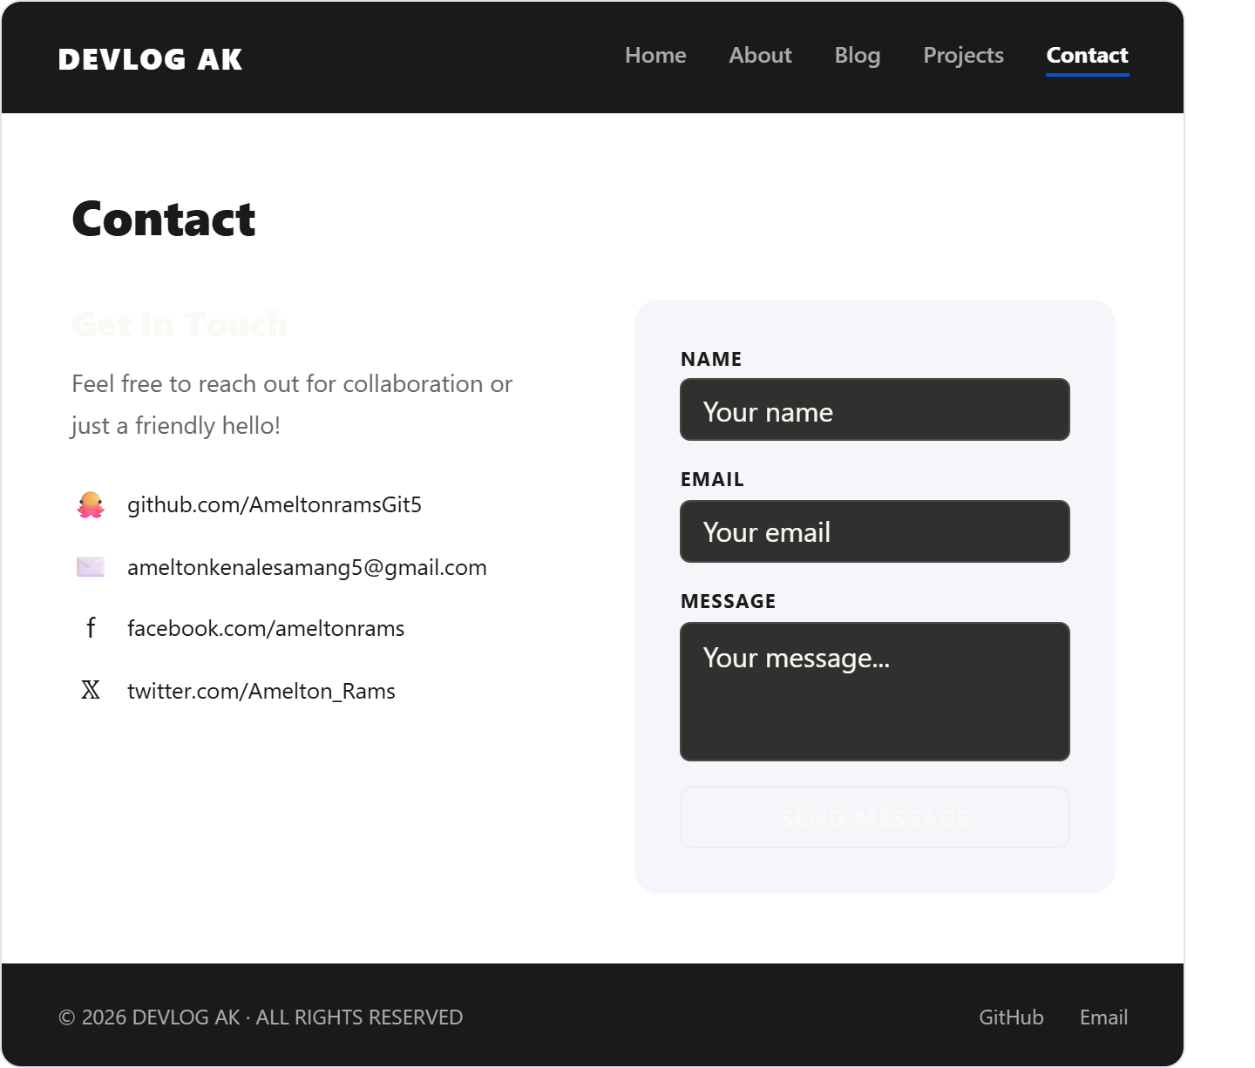

7.Technical Brief
Built using HTML, CSS and JavaScript.
HTML was used to create the structure of the website such as the navigation bar, headings, text sections, cards, images and links.
CSS was used to style the website by adding colors, spacing, fonts, layouts, hover effects and overall visual design. Inline JavaScript was used to control the buttons in the blog page behavior.
Developed using Visual Studio Code
Visual Studio Code was used as the main code editor to write and manage the HTML and CSS files and later pushed to GitHub. It helped with coding through features such as syntax highlighting, code suggestions, file management and live preview testing during development.
Hosted using GitHub Pages
The completed website files were uploaded to a GitHub repository.
GitHub Pages was then used to publish the repository as a live website so users could access it online through a web link.
Uses responsive design for mobile and desktop devices
Responsive design was created using CSS techniques such as flexible layouts, percentage widths and media queries. This allows the website to automatically adjust its layout, text size, spacing and content positioning depending on the screen size so it works properly on both mobile phones and desktop computers.

8.Quality Assurance
• Tested on Google Chrome and Microsoft Edge to check browser compatibility
• Verified responsive design on mobile and desktop screen sizes
• Validated HTML, JavaScript and CSS structure for correct coding standards
• Fixed layout alignment issues and navigation errors
• Improved page consistency and user experience across all sections

Testing.
Chrome test.
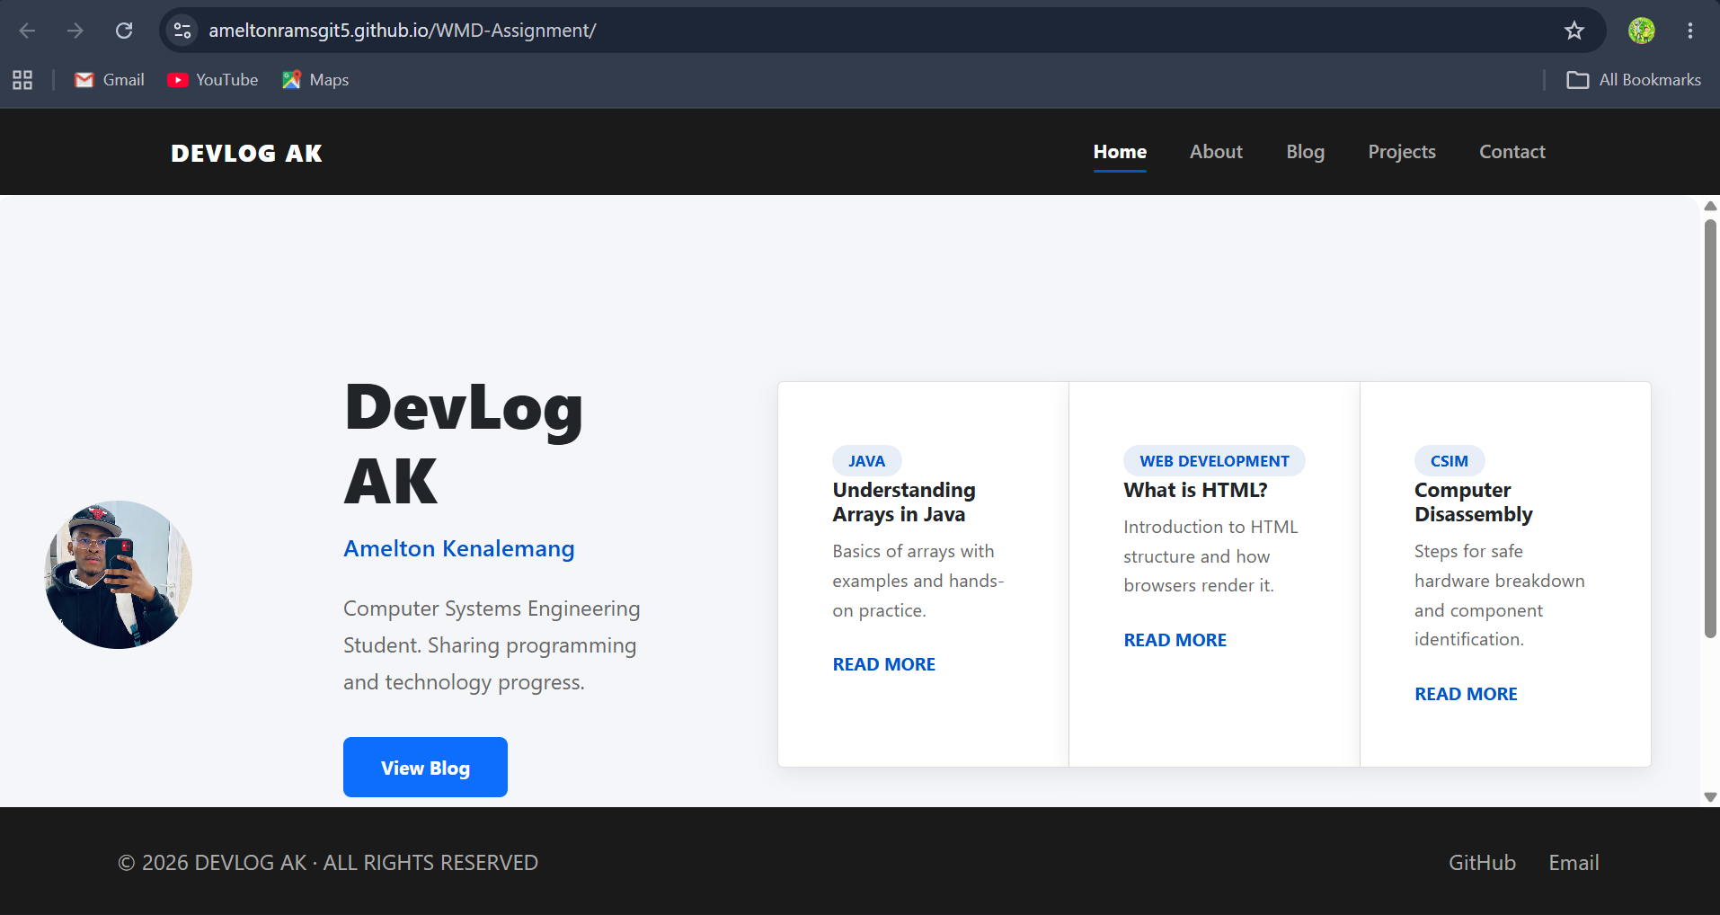
Edge browser test.
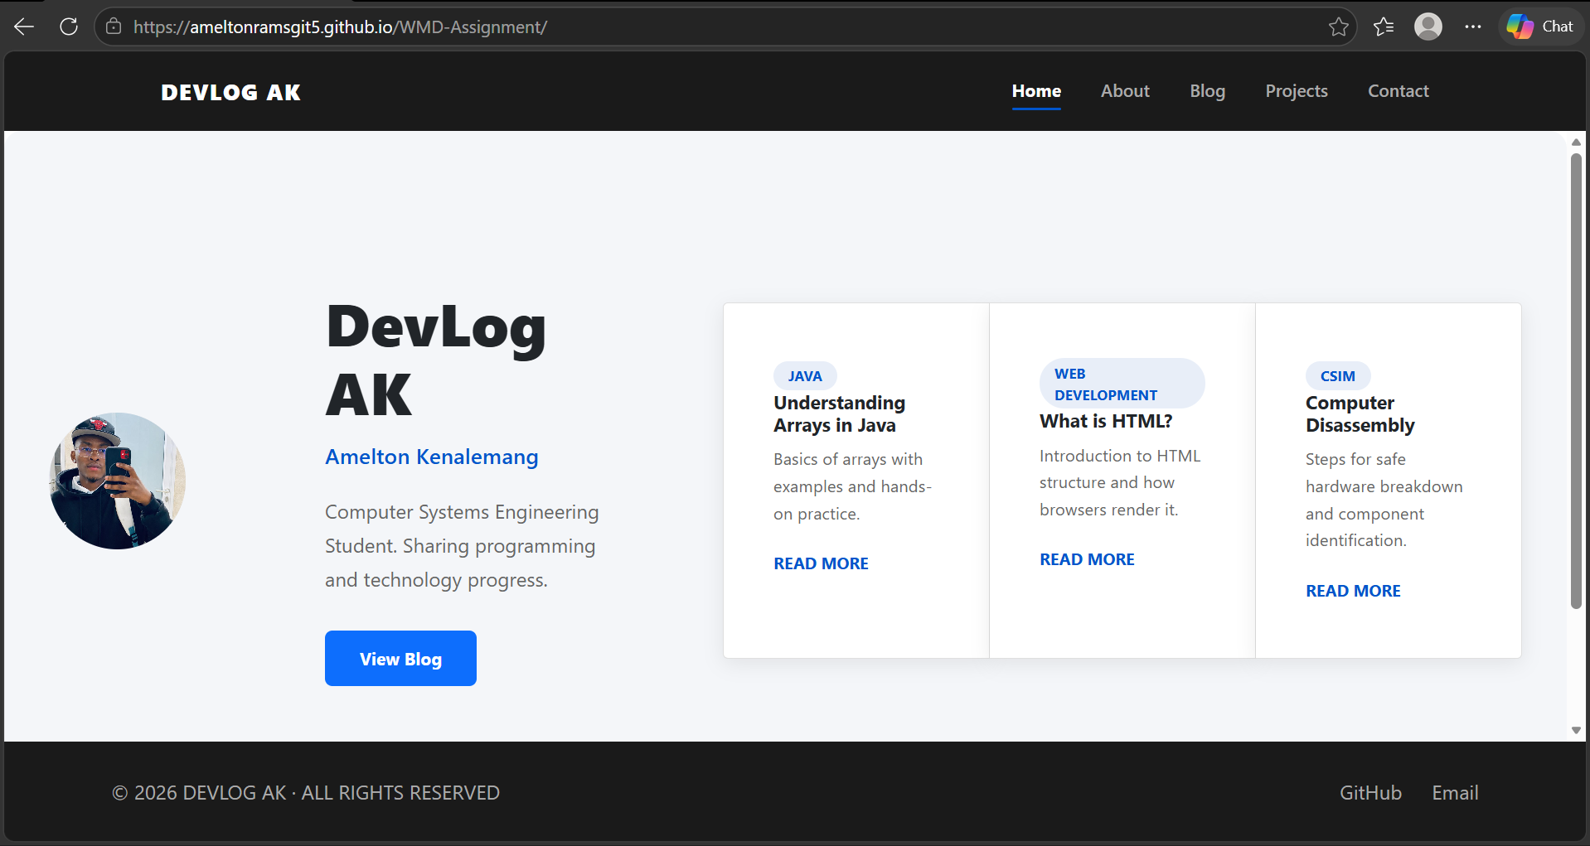
Mobile device testing.

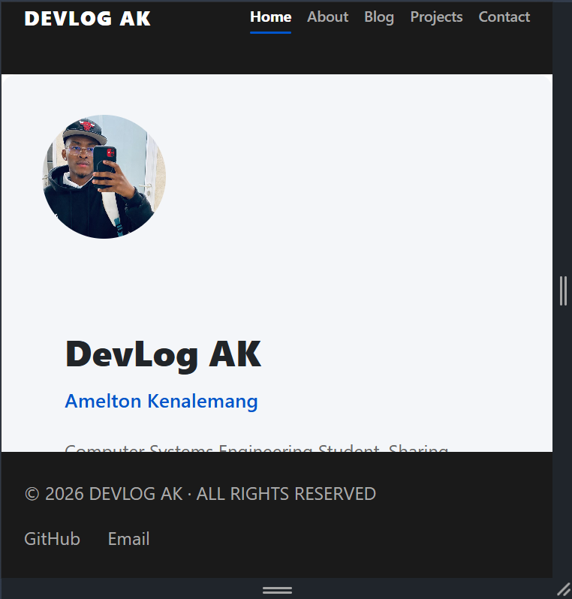

9. Publishing & Promotion
• Project uploaded to GitHub repository
• Website deployed using GitHub Pages
• Shared through personal social media and academic networks for review purposes.

10. Future Developments
• Add search function for blog posts
• Add dark/light mode toggle
• Improve blog with comments system
• Add animations for better user experience

